|  |  |
| --- | --- |
|  |  |

|  |
| --- |
| **Activity 6.1.4 Electromagnets** |

Introduction

|  |  |
| --- | --- |
|  | What do you think was the major contributing factor to the downfall of the bank robbers of the Wild West? Most historians would say that communication, specifically Morse code, put many bank robbers out of business. Before Morse code was used to send long distance messages between towns, robbers were safe as long as they could escape far from town. The advent of Morse code, however, meant that all surrounding towns could know immediately that danger was headed their way.  You may think of Morse code as a slow and difficult way to communicate. In fact, those trained to use Morse code could probably send a message faster than you can text a message to a friend. |

Equipment

* ¾ x 1 ½ x 6 in. pine board
* Ruler or tape measure
* Drill and 3/32, 1/16, 1/8 in. bits
* Glue gun with glue
* 78 in. of 22 gauge magnetic wire
* 20D nail
* Two jumbo (1 ¾ in.) paperclips
* 2 - #8 x ½ in. pan head screws
* 2 - 3 x ¼ in. rubber bands (similar sizes will work)
* D cell battery

Procedure

Build a Morse code machine: In teams of two to three, you will create an electromagnet that will function as a Morse code machine.

1. Begin with a ¾ x 1 ½ x 6 in. base and mark the following locations as dimensioned below. Number the holes as shown.

|  |  |
| --- | --- |
|  |  |

1. Drill a ½ in. deep pilot hole with a 3/32 in. bit in holes 1 and 2.
2. Drill a ½ in. deep pilot hole with a 1/16 in. bit in hole 3.
3. Drill a hole all the way through the base with a 1/8 in. bit in hole 4.
4. Sand about 2 in. of each end of 6 ft of 22 gauge magnetic wire.
5. Leave about 6 in. of extra wire and neatly wrap it around a 20D nail several times. Begin at the head of the nail. As the wire is wrapped, it should cover the nail. Stop when you have wrapped approximately about 4 in. one time around the nail.

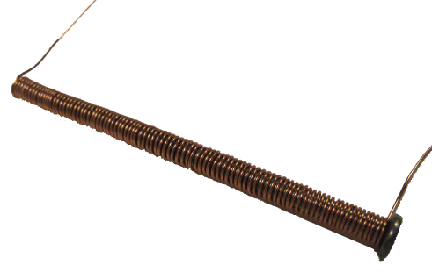

1. Hammer the nail into hole 4 until the magnetic wire is against the edge of the board.
2. Bend one paper clip as shown below.

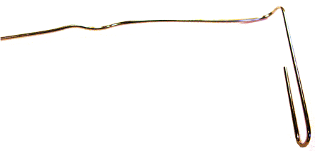

1. Position the paper clip so that it rests just above the head of the nail. Put some hot glue around the base to hold the paperclip in place.

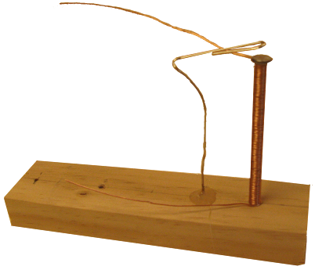

1. Drive a #8 x ½ in. pan head screw into hole 2 and trap the wire closest to the tip of the nail.
2. Cut a 4 in. piece of magnetic wire and sand about 1 in. of each end.
3. Put a slight bend in the end of a paperclip with the larger diameter.

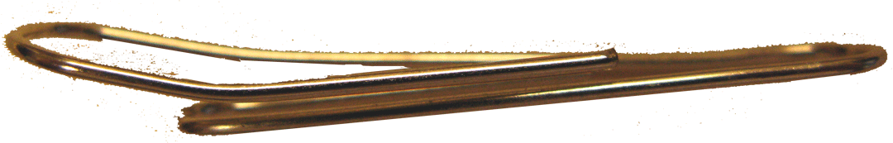

1. Drive a #8 x ½ in. pan head screw into hole 1 of the base to trap one end of the 4 in. wire and the large end of the paperclip.

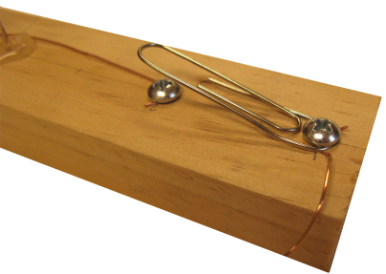

1. Create a small loop in the end of the two unconnected wires.

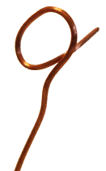

1. Use one rubber band to attach the battery to the base. Use the other rubber band to hold the wires against the ends of the battery.

Troubleshooting: If your electromagnet does not work, be sure that you have formed good connections throughout the circuit. Not only should they be touching, but you may also need to sand more of the insulation from the wire. You also may need to adjust the paperclip above the nail head. The paperclip should be barely above the nail.

Sending a message: You will now use the Morse code machine to create and interpret messages. Refer to the last page of this document to see instructions for creating messages.

1. Practice sending the message “apples are red” using the translation below.
2. Individually create a short message that you can communicate using Morse code.
3. Join another group so that there are four to six people in each group. Take turns delivering and decoding messages.

Conclusion

1. What kind of tweaks did you make to get your Morse code machine to work?

I adjusted the position of the paperclip to improve the sound and adjusted the wires to make sure the connection was strong.

1. What portion of the machine was the electromagnet?

The wire wrapped around the nail.

1. What portion of the machine acted as the key which broke or connected the electrical circuit?

The paperclip.

1. Does it make a difference which end of the battery is connected to the electromagnet?

No

1. Describe a machine or situation where it is important to have the ability to turn magnetic power on and off.

A magnetic crane would need to be able to turn on to pick up metal, and have the ability to turn off the drop the metal.

|  |  |  |  |  |  |  |  |  |  |  |
| --- | --- | --- | --- | --- | --- | --- | --- | --- | --- | --- |
| International Morse Code   * + 1 dash = 3 dots   + Space within a word = 1 dot   + Space between letters = 3 dots   + Space between words = 7 dots | | | | | | | | | | |
| Morse Code Example | | | | | | | | | | |
| A |  | P |  | P |  | L |  | E |  | S |
| • – |  | • – – • |  | • – – • |  | • – • • |  | • |  | • • • |
|  |  |  |  |  |  |  |  |  |  |  |
| A |  | R |  | E |  |  |  |  |  |  |
| • – |  | • – • |  | • |  |  |  |  |  |  |
|  |  |  |  |  |  |  |  |  |  |  |
| R |  | E |  | D |  |  |  |  |  |  |
| • – • |  | • |  | – • • |  |  |  |  |  |  |
|  | | | | | | | | | | |
|  | | | | | | | | | | |